Ansible Assignment – 2

Data Persistence using Docker Volume

1. Create 2 AWS ubuntu instance

.

1. Setup Ansible on one instance.
2. Setup hosts inventory file.
3. Take the Spring boot application.

1. Containerize the Spring boot Application

6. Write an Ansible role to configure another node with following –

• Docker Engine

• Create Unix user and group named (demo)

• Deploy the Spring Boot App.

7.Verify the Application by accessing it in the browser.

1. Create 2 AWS ubuntu instance
2. Setup ansible on one instance.



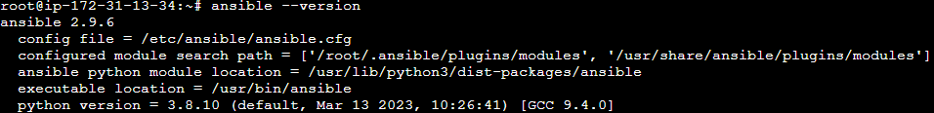

1. Setup host inventory file.

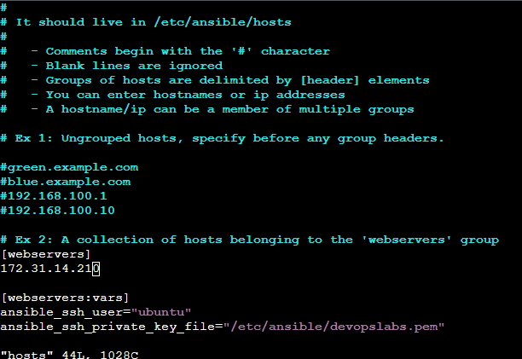

4. Take the Spring boot application.

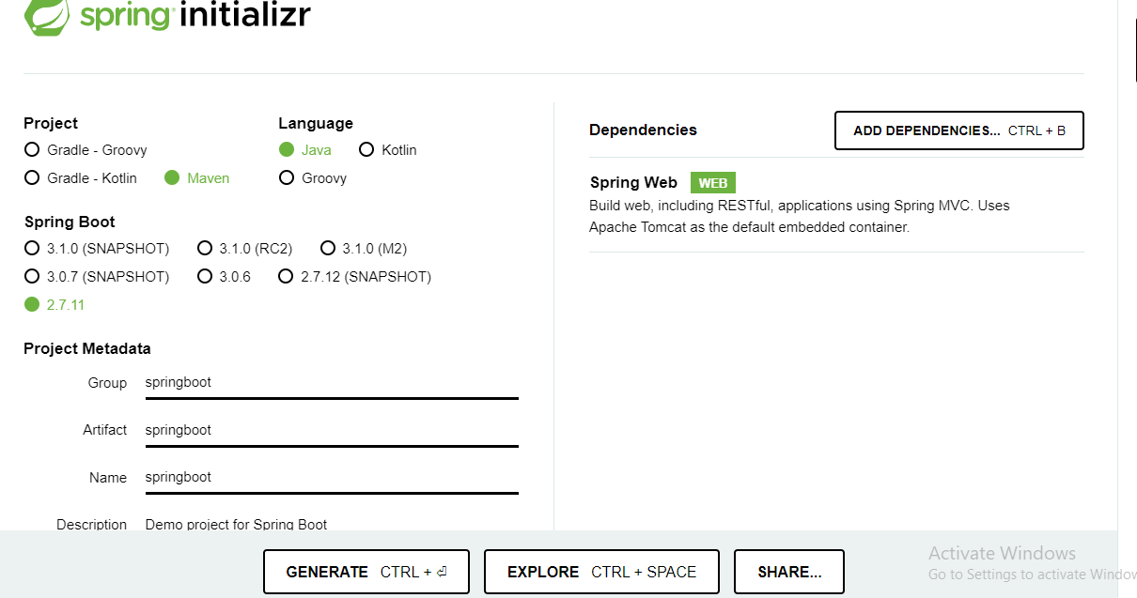

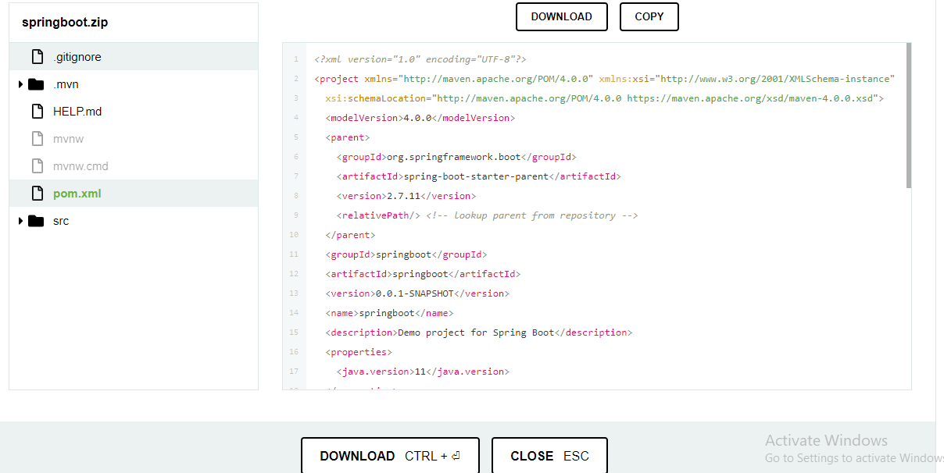

ansible l2 4.2

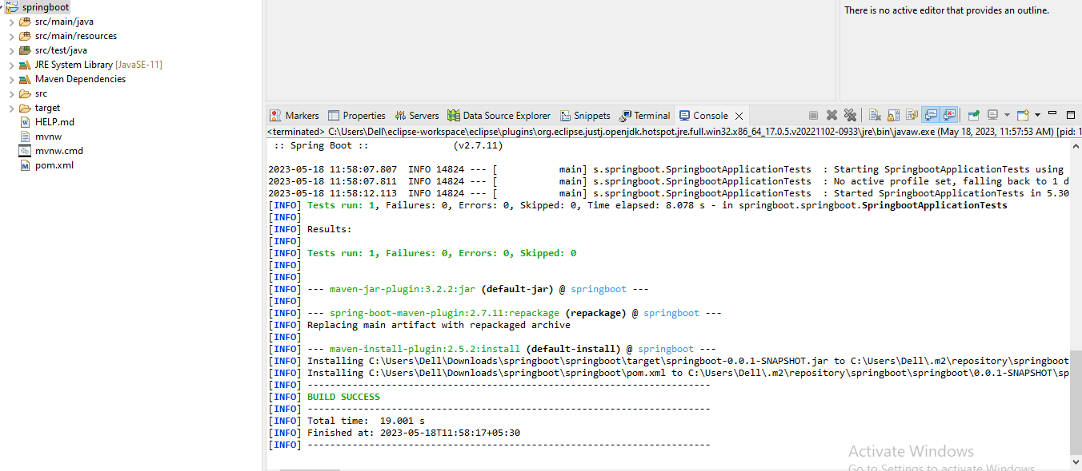

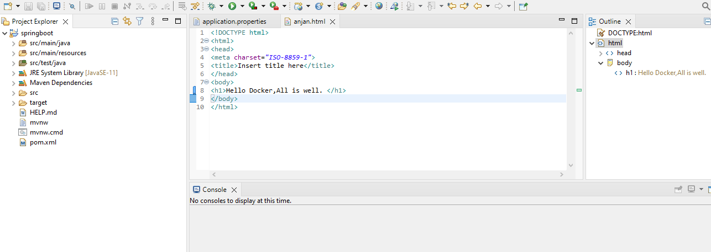

5. Containerize the Spring boot Application

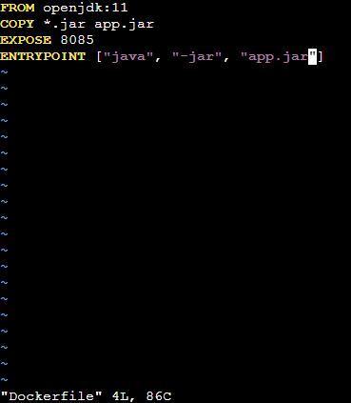

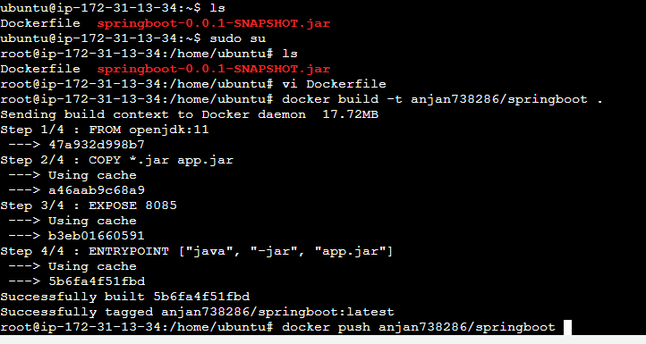

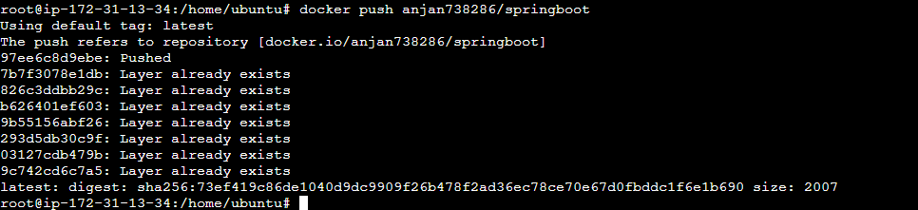



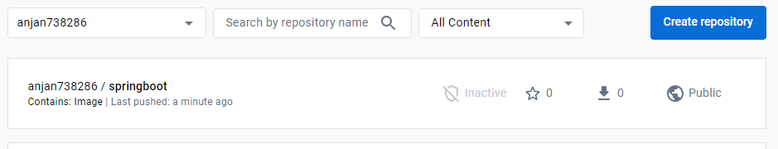

6. Write an Ansible role to configure another node with following –

• Docker Engine

• Create Unix user and group named (demo)

• Deploy the Spring Boot App.

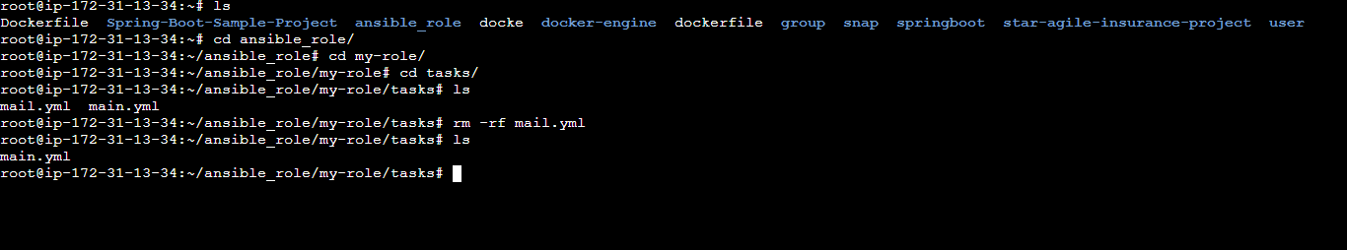

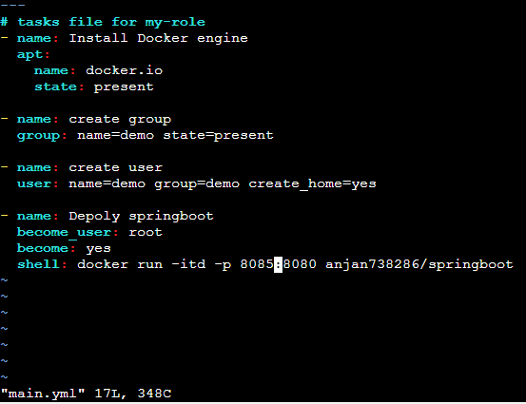

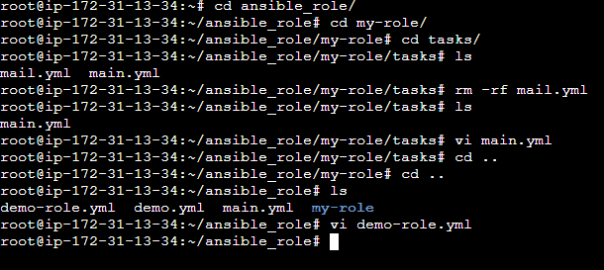

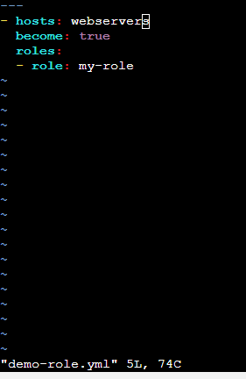

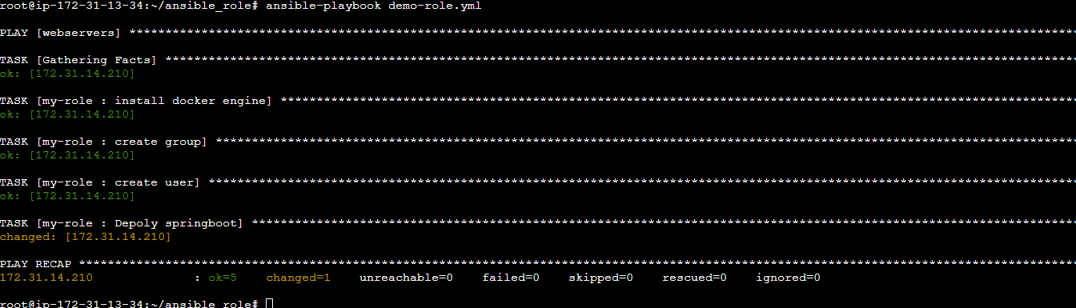

7.Verify the Application by accessing it in the browser.

